
Jolly Helmet
Make your Helmet Happy Again!
Clean it. Dry it.
Wear it happy.
Coin-operated helmet cleaning and drying stations
MEJES, JERAHMEEL ALZEL M.
CRUZ, DEAN RYAN P.
MENDOZA, RICAH S.
MARTOS, KRISTINA E.
DEVELOPERS AND DESIGNERS
USER MANUAL - ADMIN GUIDE

Jolly Helmet User Manual
Admin guide (Control Center)
Revision 11, 4 November 2026. Made by MEJEZ STUDIO.
This book is one of three: Customer guide, Admin guide, Technician guide (with the Reference). The full manual, with everything in one file, is JollyHelmet_UserManual_v11.pdf.
Two PDFs come with this book. The plain file (single pages in reading order): print double-sided, flip on the LONG edge, Letter size (A4 at 'fit'). The file whose name ends in _BOOKLET (two pages on each landscape sheet, the last page next to the first): print double-sided, flip on the SHORT edge, 100 percent (actual size), then fold the whole stack in half and staple on the fold. Every chapter starts on a right-hand page; the page count is a multiple of 4 so the booklet folds cleanly.
Questions or faults: MEJEZ STUDIO, 0975 791 5832.

Contents
Admin guide (Control Center) 5
Connecting 6
Home page 7
Box settings (coins, sensors, auto-dry) 15
Screen refresh and maintenance 17
Refilling Station 20
Troubleshooting and care 25
Online page (Monitor, Alerts, Reports) 27
Reference (Safety, settings, policies and glossary) 33
Safety and emergencies 34
Settings reference 37
Policies 41
Glossary 43
Index 47

Admin guide (Control Center)
The Control Center: settings, calibration and maintenance
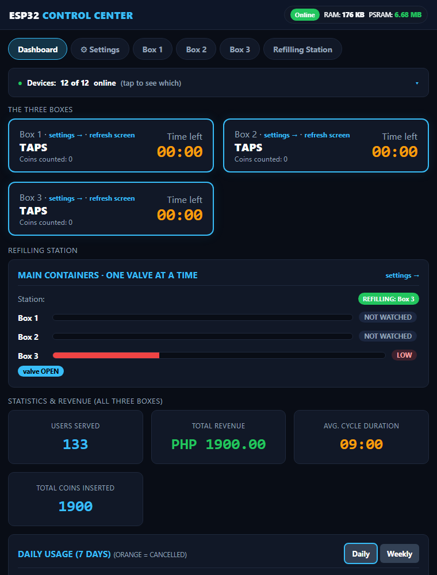
WEB PANEL FOR ADMINS AND TECHNICIANS

Connecting
The Control Center is a small web server (the LocalServer) inside the machine. You connect to it with a phone or laptop. It does not need internet.
- Switch on the machine and wait about 30 seconds.
- On your phone, join the Wi-Fi JollyHelmet-Local, password 12345678.
- Open a browser and go to http://192.168.4.1. On most phones the page opens by itself (a captive portal); if it does not, type the address.
- The Dashboard appears. The bar at the top (Dashboard, Settings, Box 1, Box 2, Box 3, Refilling Station) takes you to every page; the same bar is at the top of every settings page.

The machines keep running and keep every setting even when the LocalServer is off or being replaced. It only shows, and sends your changes.

The Wi-Fi password is printed here for admins. Change it in the LocalServer program if this manual is shared outside the team.

Home page
- Dashboard (older pages and the flowcharts call it Home): the first tab of the Control Center. The bar at the top takes you to every other page.
- Alert banners (red): the Refilling Station offline, a refill that failed, a box out of order, and the two memory and log-storage notes (see Warnings and crash reports).
- Navigation bar: Dashboard, Settings, Box 1, Box 2, Box 3 and Refilling Station (the same bar is on every page).
- The three boxes: current step, coins counted, time left, plus settings and refresh screen links.
- Refilling Station: the main container levels (EMPTY to MAX; Box 1 and Box 2 say NOT WATCHED for now), who is waiting, which valve is open and a failed refill. Its settings link opens the Refilling Station page.
- Statistics: users served, total revenue, average cycle time and coins, the Daily and Weekly usage chart, the day viewer and the Finished and cancelled tally.
- Devices line: how many boards are online. Tap it for the online or offline badge of every board.

Navigation bar and the Devices line
The same navigation bar sits at the top of every page: Dashboard, Settings, Box 1, Box 2, Box 3 and Refilling Station. Tap a name to go there; the page you are on is highlighted. Below it the Devices line tells you how many boards answer (for example 12 of 12 online). Tap it to open the list with an ONLINE or OFFLINE badge for every board.
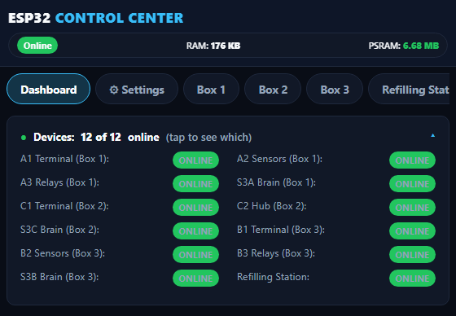
The navigation bar and the Devices list (tap the Devices line to open it)

Daily usage and the day viewer
The chart shows how many customers came each day (Daily, the last 7 days) or each week (Weekly). Orange is the part that was cancelled. A lighter shade is the previous data collected by the team after the upgrade (see the Settings tab below).
- Tap a bar of the Daily chart, or pick a date and tap Show the customers, to open that day customer by customer: time, box, coins, pesos, Finished or Cancelled, and minutes.
- The two tabs Machine and JSON only tell you where each row came from: Machine is what the machines recorded, JSON is what the team added from its own records. Both are real customers.
- Sessions without a date finished before a phone set the clock. They get their date as soon as the clock is set.
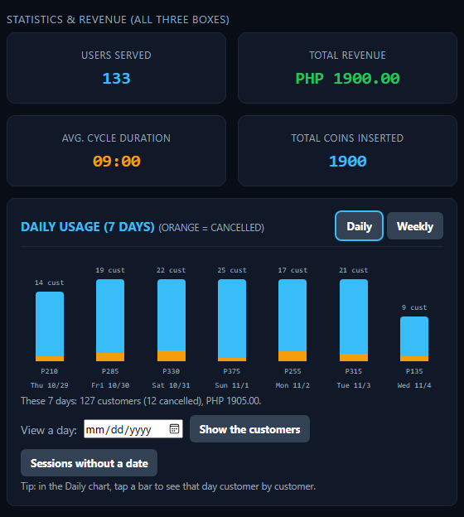
Statistics and the usage chart (lighter bars = previous data)

Finished and cancelled sessions
This card is the whole tally from the first day in one table: users served, coins, revenue and average time, for Finished and for Cancelled. Finished means the cycle ran to the end. Cancelled means the customer aborted in the middle; the coins that were paid still count as revenue. The line under the table says how much of the numbers came from the JSON file and how much the machines counted themselves, so nobody has to add two tables together.

A payment that is cancelled on the INSERT COIN screen is not counted as a session.

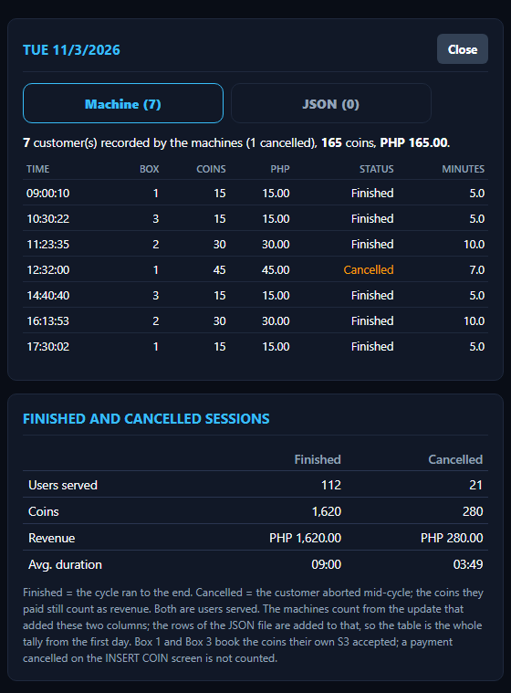
One day opened customer by customer (Machine tab), and the Finished and cancelled tally below it

Settings tab: clock, session log, backup and previous data
The Settings tab holds what you set once and rarely touch.
- Clock: the LocalServer has no clock of its own. A phone sets it when the Control Center is opened after a power-on, or you type the date and time. A power cut loses it.
- Session log: every session the machines report is saved with its date and time (never a name). The bar shows how much storage is used. Entries older than a year are dropped by themselves.
- Download log (CSV): this is the backup. Download it now and then and keep the file.
- Restore from backup CSV: if the log is ever lost (a power cut damaged the storage, or Reset Stats was tapped by mistake), choose the CSV here and tap the button. Only an unchanged download is accepted: the last line of the file is a check that is refused if anything was edited or the file was saved again in a spreadsheet. Sessions already on the board stay, nothing is added twice, and the totals are raised to at least the log's tally.
- Previous data (history.json): customers from before the log existed. The team builds the file on a PC (the layout is in HISTORY_FILE.txt in the LocalServer folder) and uploads it here. The chart draws it lighter and the Finished and cancelled card adds it. It never changes the machine log, the totals or the CSV.
- Coin value (pesos per pulse) and Reset Stats: Reset Stats empties the counters and the machine log, so download the CSV first. The history file stays.
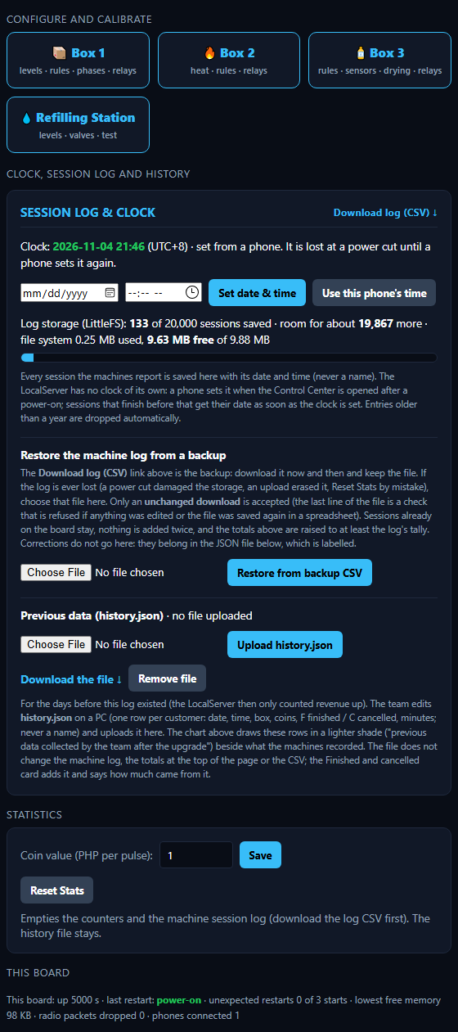
Settings: clock, session log, restore from a backup CSV and the previous data

The check line of the CSV stops mistakes and casual edits. It is not a lock. A correction to the data does not go into the machine log: it belongs in the JSON file, which is labelled as the team's own records.

Warnings and crash reports
Two red notes can appear on top of the Dashboard. The first says the board found damage in its memory. The second says the log storage was damaged and was re-created empty at the last start: open Settings, restore your last backup CSV, and upload the history file again if you use one.
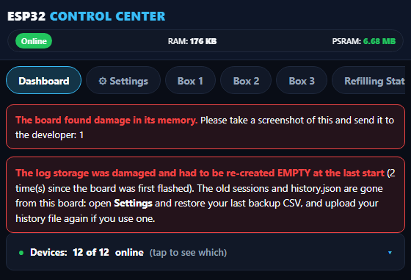
The two red notes on the Dashboard
If the unit ever restarts by itself you do not need a laptop. Open Settings and look at This board. The last restarts are kept in the board's own flash (a power cut does not erase them). Tap Crash reports kept on this board, take a screenshot and send it to the developer. Delete these reports clears the list.
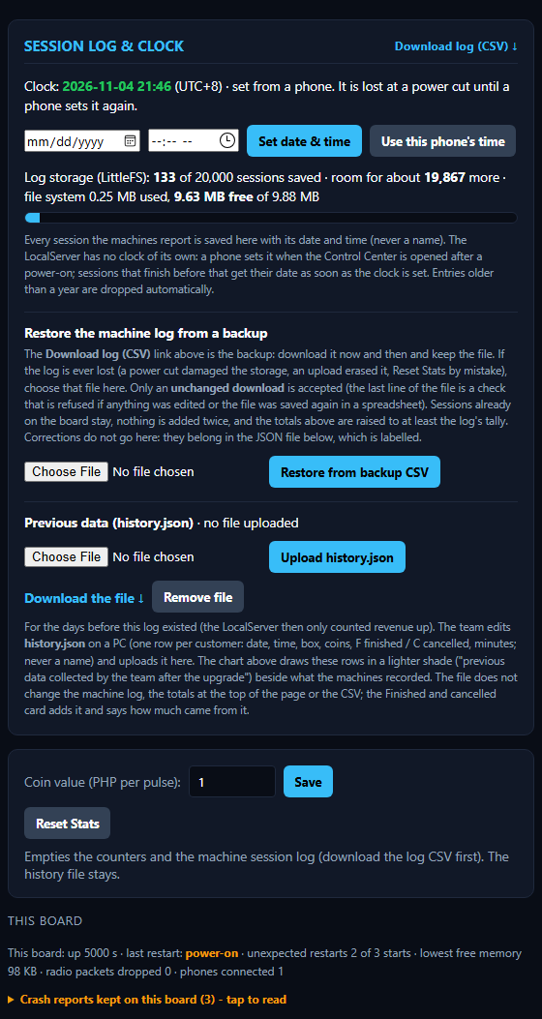
Settings, This board: the stored crash reports

Box settings (coins, sensors, auto-dry)

Settings on a box page
Box 1, Box 2 and Box 3 run the same flow, so every box page has the same sections (the pictures show the Box 3 page). Open a box from the navigation bar. The coins decide how long a run lasts; four sections matter, and the Screen, OPEN A / OPEN B beep and Maintenance sections further on are on the same page.
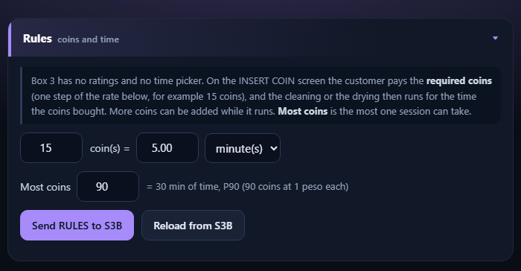
A box page, Rules (coins and time)
- Rules (coins and time): N coins = X minutes (default 15 coins = 5 minutes) and Most coins (default 90). The first N coins are the required coins on the INSERT COIN screen; each coin buys the same share of time (20 seconds at the default). Tap Send RULES.
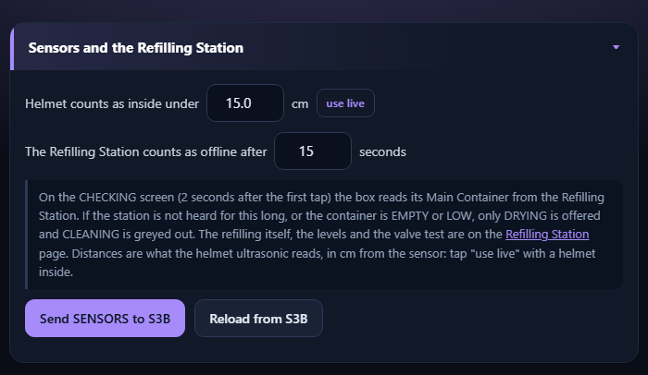
A box page, Sensors and the Refilling Station
- Helmet counts as inside under: put a helmet in, tap use live, raise the number a little (1 to 200 cm, default 15). The screen board and the relay controller use the same number to decide when a helmet is trapped during OUT OF ORDER, and keep it in their own memory, so a power cut does not lose it.
- The Refilling Station counts as offline after: 5 to 120 seconds (default 15). If the station is not heard for this long, or the container is EMPTY or LOW, only DRYING is offered. Tap Send SENSORS.
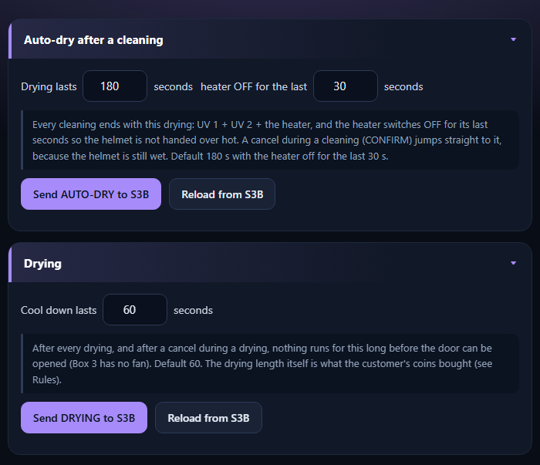
A box page, Auto-dry after a cleaning and Drying
- Auto-dry after a cleaning: how long it lasts (10 to 900 seconds, default 180) and how long the heater is off at the end (0 to 900, default 30). A cancel during a cleaning jumps straight to it. Tap Send AUTO-DRY.
- Drying: the cool-down seconds (5 to 900, default 60), also after a cancelled drying. The drying time is what the coins bought. Tap Send DRYING.

Good to know
- Every setting is saved inside the box's own board, so it survives a power cut or a LocalServer replacement.
- If a number is outside its allowed range, the box refuses it. The green tick will not appear.
- Use Reload beside a Send button to bring back what the box really has.

Change one thing at a time and test it with a short session before leaving it.

Screen refresh and maintenance

Screen (touch display)
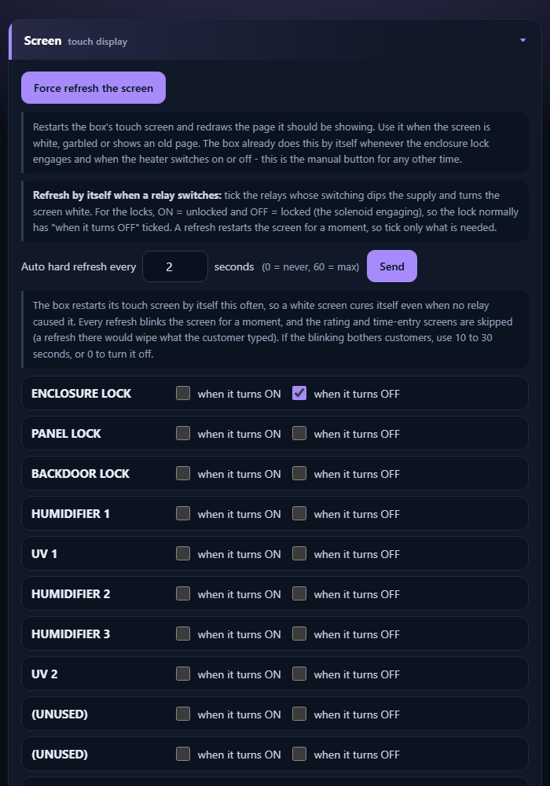
A heavy load switching on can make the touch screen go white. Three tools cure it:
- Force refresh the screen: restarts it now.
- Auto hard refresh every N seconds: restarts it by itself (0 = never, 60 = max).
- Refresh when a relay switches: tick the relays (ON and/or OFF) that should trigger it. The lock is normally ticked OFF.

OPEN A / OPEN B beep
While a box waits at OPEN A or OPEN B for the door to be opened, it beeps again and again (beep, wait, beep, wait) until the door opens. You set the length of the beep and of the wait on each box page, in the section OPEN A / OPEN B beep.
- Beep for 20 to 1000 ms, then wait 0 to 10000 ms. A wait of 0 gives one beep only.
- Tap Send. The box keeps the values in its own memory. The default is a beep of 100 ms and a wait of 500 ms.
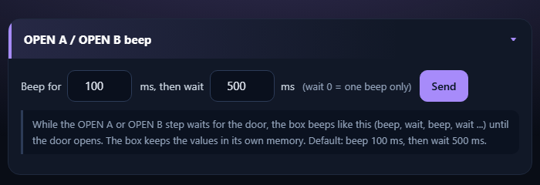
The OPEN A / OPEN B beep section of a box page

Maintenance mode
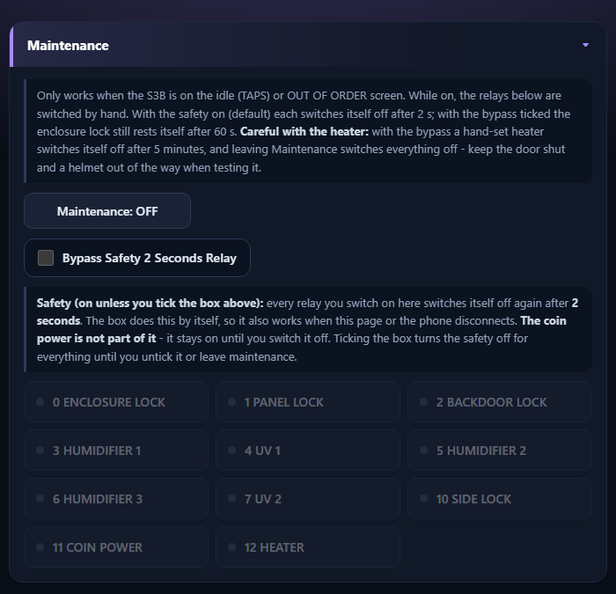
- Make sure the station is on its start screen (TAPS) or OUT OF ORDER.
- Tap Maintenance. The machine shows MAINTENANCE.
- Tap a relay button to switch it on by hand. Green = on. With the safety on it switches itself off again after 2 seconds (see below); tap it again to repeat.
- Tap Maintenance again. Everything switches off.

With the safety on, a relay you switch on by hand goes off by itself after 2 seconds. With the bypass ticked the heater turns itself off after 5 minutes and the lock after 60 seconds. Keep the door shut and clear when testing the heater.

The 2-second safety
So that a forgotten tap cannot leave a lamp, a humidifier, the heater or a lock running, every relay you switch on in Maintenance switches itself off again after 2 seconds. The box does this by itself, so it also works if the phone or the page disconnects.
- Bypass Safety 2 Seconds Relay: tick it when a relay must stay on, for example to watch a humidifier make mist. The safety is then off for every relay until you untick the box or leave Maintenance. The heater still turns itself off after 5 minutes and the enclosure lock rests after 60 seconds.
- The coin power is not part of the 2-second safety. It stays on until you switch it off.

Refilling Station
One small board (the Refilling Station) keeps the main container full. For now it watches and refills Box 3 only: Box 1 and Box 2 are still being worked on and show NOT WATCHED. The board is built for three containers (three water-level sensors, three valves, one water supply) so Box 1 and Box 2 can be switched on later. It works alone: the boxes never ask it for anything, they only listen to what it reports.
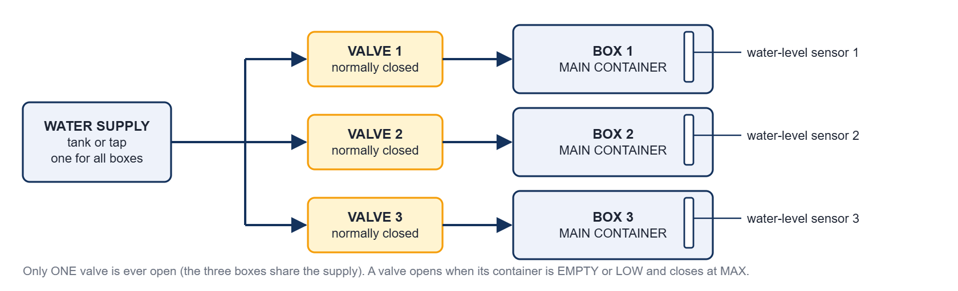
The water path: one supply, three normally closed valves, three main containers with a water-level sensor each

How it works
- Every second the station reads the sensor of each container it watches (Box 3 for now) and works out the level: EMPTY, LOW, MID, HIGH or MAX.
- A container that is EMPTY or LOW joins the queue. EMPTY containers go first, LOW second; inside a group the one that waited longest goes first.
- Only one valve is ever open. A refill that is running is never interrupted. The valve closes when the container reaches MAX.
- If the level does not rise (30 seconds while EMPTY, 5 seconds while LOW, or the valve has been open 3 minutes) the refill FAILED: the valve closes, a flag is set and the station tries again after 60 seconds, for ever.
- The station tells everybody the levels every second. A box offers CLEANING only when the station was heard in the last 15 seconds and its container is MID or higher; otherwise only DRYING.
- The water supply has no sensor of its own. An empty supply shows as a refill that does not rise.
- Box 1 and Box 2 are not watched for now. The station reports them as NOT WATCHED (no level, no warning), never queues them, never opens their valves and refuses the manual test of their valves. Their sensors and valves can stay unconnected.
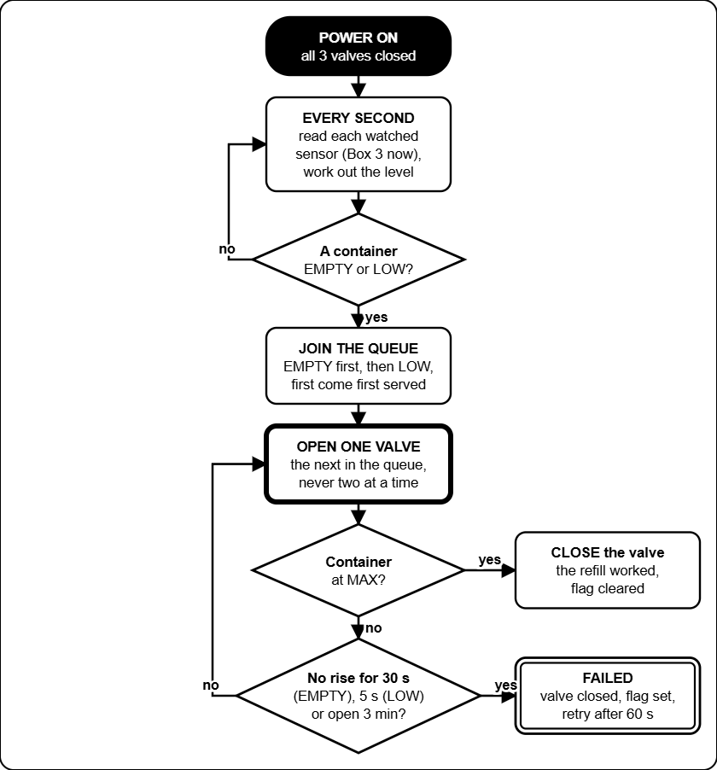
What the Refilling Station does, from power-on

Reading the Refilling Station page
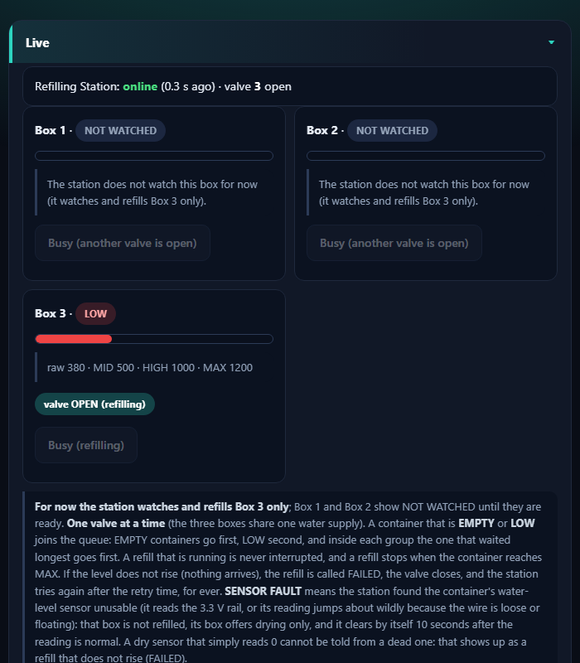
The Live card: station online, Box 3 refilling with its valve open, Box 1 and Box 2 not watched (example)
- The top line says whether the station is online, which valve is open and who is waiting.
- Each box has a card: its level (EMPTY, LOW, MID, HIGH, MAX), a bar, the raw reading with the MID, HIGH and MAX numbers, and a tag: valve OPEN (refilling), waiting for its turn, full, or FAILED. A box the station does not watch says NOT WATCHED and its test button is greyed out.
- The same levels sit on the Dashboard under Refilling Station, and on the online page as dials.

Setting up the levels
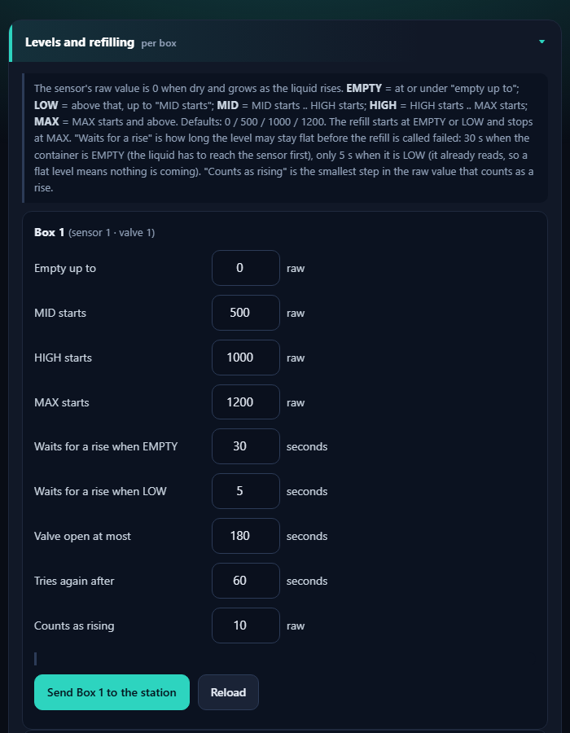
Levels and refilling, one form per box (Box 1 shown; only Box 3 is used for now)
- Dry sensor: note the raw value on the Live card. Then put the sensor in the real liquid at the level you want to call LOW, MID, HIGH and MAX, and note the raw value each time (it is 0 when dry and grows as the liquid rises).
- Type the four edges for that box: Empty up to, MID starts, HIGH starts, MAX starts (they must grow in that order, up to 4095). Defaults: 0, 500, 1000, 1200.
- Tap Send Box 1 to the station (or 2, 3). A green tick means the station saved it. Copy Box 1's numbers into Box 2 and Box 3 fills the other forms when the containers are alike.

Field | What it does | Default | Range
Empty up to | At or under this raw value the container is EMPTY. | 0 | 0-4095
MID, HIGH, MAX starts | Where each level starts. A refill starts at EMPTY or LOW and stops at MAX. | 500 / 1000 / 1200 | 1-4095
Waits for a rise when EMPTY | How long the level may stay flat while EMPTY before the refill FAILED (the liquid first has to reach the sensor). | 30 s | 1-600 s
Waits for a rise when LOW | The same while LOW (the sensor already reads, so flat means nothing arrives). | 5 s | 1-600 s
Valve open at most | Longest time one valve may stay open. | 180 s | 10-1800 s
Tries again after | Pause before a failed box tries again. | 60 s | 5-3600 s
Counts as rising | Smallest step in the raw value that counts as a rise. | 10 | 1-500

Test a valve by hand
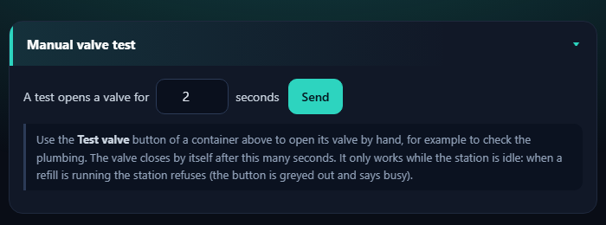
Manual valve test
- Set how long a test opens the valve (default 2 seconds, 1 to 30), tap Send, then tap Test valve on a container's card. The valve closes by itself.
- It only works while the station is idle. During a refill the button is greyed out and says busy. A test does not touch the queue or the failed flags. Box 1 and Box 2 cannot be tested for now.
- Do the first test with the supply connected and a bucket under the tube, one valve at a time.

When a refill fails
- The tag FAILED stays on until a refill works, or the container reads MID or higher for 3 seconds (somebody filled it by hand). The Online Server and the web page raise a warning.
- A sensor that reads 0 by mistake (unplugged, wrong wire, probe out of the liquid) looks like an EMPTY container, so the station keeps trying (valve open up to 30 seconds, then a pause of 60 seconds). The sensor check (next part) catches a wire on the 3.3 V rail and a floating wire, but not a dead sensor that reads 0. If a container is really full, close the supply and fix the sensor wire first. A drip tray under the containers is a good idea.
- Check the supply (tank full, tap open), then the decision tree "The Refilling Station does not fill" in the Technician book (Reference chapter). The station keeps trying every 60 seconds by itself.
- If the station itself is not heard (OFFLINE on the Dashboard), every box offers DRYING only. That raises a critical alert on the online page.

Is a sensor still working?
The station checks every water-level sensor all the time. It cannot see inside the container, so it only catches the faults that show in the reading.

What the station sees | What it does | Caught?
The reading sits on the 3.3 V rail (4090 or more), for 5 seconds | SENSOR FAULT: the box offers drying only, is not refilled, and a warning shows on the Dashboard, the Refilling Station page and the online page. It clears by itself 10 seconds after the reading is normal. | Yes
The reading jumps about by more than 1500 inside one second while the valve is closed, for 5 seconds (a loose, broken or floating SIG wire) | The same SENSOR FAULT. | Yes
A dry sensor that reads 0 and a dead sensor that reads 0 | They look the same. A container that never rises while its valve is open is called a FAILED refill; the station tries again. | Not by the value alone

Check a sensor by hand:
- Open the Refilling Station page and watch the raw value of that box. Dry, it reads about 0 and stays steady. Put the probe in water: the number rises and the level changes. Take it out: it falls again.
- Wiggle the SIG wire. The reading must not jump about.
- On the serial console (115200) type sensors: it prints, for every sensor, the average, the smallest and biggest reading of the last second, the spread, and whether it looks fine. raw streams the readings.
- Use Test valve on a container that is not full: with the supply on, the raw value should climb after a few seconds.

When the hardware team has chosen the sensor, pull its SIG wire and type sensors. If a disconnected wire reads something different from a dry sensor, the limits can be tuned to catch that too.

Troubleshooting and care

Troubleshooting

Problem | What to do
Screen white or garbled | Box page, Force refresh the screen. If it returns, tick the relay that causes it or lower the auto-refresh time.
A board shows OFFLINE | Check its power and wiring, then watch its badge in the Devices list on the Dashboard.
Station shows OUT OF ORDER | One board of that box is silent (sensors or relay controller, or the main controller itself). See the offline badges. A helmet inside is released by itself: the door unlocks and the screen board beeps.
Only DRYING is offered (SELECT DRY ONLY) | The Refilling Station is offline, or the box's container is EMPTY or LOW. Open the Refilling Station page: check the station is online, then the supply and the valve (Refilling Station chapter).
Coins not counted | Use the coin check on the box page: pulses should rise by the coin's value.
Touch is off or upside down | The terminal needs its touch calibration or rotation checked.
Settings, This board, says last restart BROWNOUT | Power dipped. Use a stronger supply and a short cable.
Door will not open, helmet stuck | Wait for the run to end, or tap CANCEL, then CONFIRM. If the screen does not answer: box page, Maintenance, ENCLOSURE LOCK (Decision tree: The door will not open). With the power off the lock stays shut until the power is back.
A red note says the board found damage in its memory, or the unit restarted by itself | Settings, This board, Crash reports kept on this board. Take a screenshot and send it to the developer. The reports stay after a power cut.
A red note says the log storage was damaged and re-created empty | Settings, Restore from backup CSV with your last downloaded log. Upload the history file again if you use one.
A relay in Maintenance switches itself off | That is the 2-second safety. Tick Bypass Safety 2 Seconds Relay to keep it on, and untick it when you are done.
A phone cannot find the Control Center | Join the Wi-Fi JollyHelmet-Local (the old name ESP32_LOCAL is no longer used). Then open http://192.168.4.1.
A helmet is inside during a power cut or OUT OF ORDER | The station unlocks the door by itself and the buzzer beeps (screen board, relay controller and sensors must still have power). If it stays locked, follow the decision tree "The door will not open".
The online page does not show a Checklist, Fix it or Manual tab | They were taken out on 2026-10-23. The monthly checks are in the Technician guide (Maintenance) and the decision trees are in the Technician book (Reference chapter).
A container shows SENSOR FAULT | The Refilling Station found its water-level sensor unusable (reading on the 3.3 V rail, or jumping about). Check the SIG wire and the probe. That box offers drying only and is not refilled until the reading has been normal for 10 seconds.
A box shows NOT WATCHED on the Refilling Station page, the Dashboard or the online page | The station is set to watch and refill Box 3 only for now. That is normal for Box 1 and Box 2. They are switched on later (WATCH_BOX in ESP32_REFILL.ino, then reflash the station).

Care and spare parts

Daily check
- Dashboard: the Devices line says every board is online, no red banner.
- Open the Refilling Station page: the station is online, no container is FAILED, and the water supply is connected and full.
- Check the revenue and the number of users.

When a board breaks
- Keep one spare ESP32 per role, flashed and labelled (A1, S3B, Refilling Station...).
- Swap it in and wire it exactly like the old one.
- Watch its badge turn ONLINE in the Devices list on the Dashboard, then re-enter that box's settings if they were lost.
- After rewiring, test each relay by hand in Maintenance first.

S3A, S3B, S3C and the LocalServer are ESP32-S3 boards (16 MB, OPI PSRAM). The relay boards A3 and B3 must be plain ESP32 boards.

Online page (Monitor, Alerts, Reports)
The online page shows your machines on a phone or a PC, wherever you are. It only watches: nothing on it can start, stop or change a machine. Open it with the address your technician gave you. The first time it asks for the Blynk token: paste it once, it stays in that browser.

The tabs

Tab | What it is for
Monitor | The live state of every box (drawn as a little machine), the level dials of the three containers read by the Refilling Station, the network map, the revenue and the customers served.
Alerts | What needs attention now, a log of what happened, and the sound of each alert.
Reports | Revenue and customers per day, the busiest hours and days, what each box earns. CSV files and a printable report.
QR button | The QR code and a printable sign for the customer page. Stick the sign on every machine.

Level dials
Every box has a dial for its main container, read by the Refilling Station. The dial is red when the container is EMPTY or LOW (the box then offers drying only), yellow at MID, yellow-green at HIGH and green at MAX. A small valve symbol above a dial lights blue while the station is filling that container. A box the station does not watch (Box 1 and Box 2 for now) has a grey dial that says NOT WATCHED and raises no alert. So you can see a problem before a customer does.
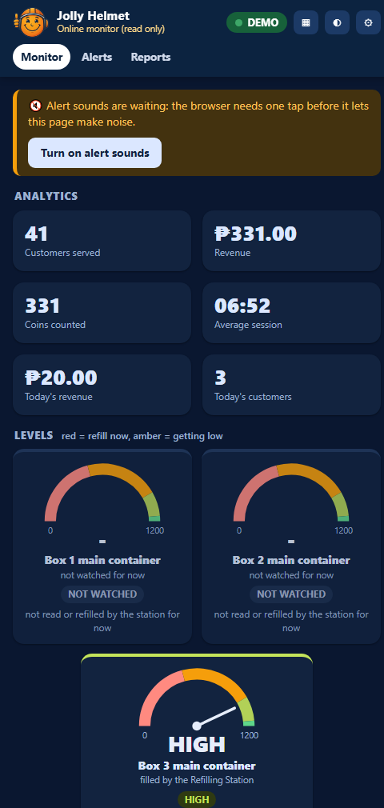
The Monitor tab: alerts at the top, the level dials, then the machines (demo data)

Alerts and sounds
When something needs attention the page shows a banner, puts a number on the tab and the tab icon, and plays a sound. Every kind of alert has its own sound, so you can tell them apart without looking.

Alert | Level | Sound | What to do
A box is OUT OF ORDER | Critical | Siren. Repeats. | See the decision tree "A box shows OUT OF ORDER" in the Technician book (Reference chapter). Usually a board of that box is offline.
No board is heard at all | Critical | Alarm. Repeats. | Check the power and the radio at the site. Decision tree: A board shows OFFLINE.
A door was opened during a run | Warning | Three rising beeps, twice | The run continues when the door is shut. Find out why it was opened.
Cleaning is switched off (SELECT DRY ONLY), a refill failed, a board is offline | Warning | Two tones (ding-dong) | Open the Refilling Station page and the Dashboard. Use the decision trees.
The data is old, or Blynk cannot be read | Warning | Falling tones | Check the internet at the site and the Online Server. Decision tree: The web page says OLD DATA.
An alert cleared | Info | Chime | Nothing: it is back to normal.
The Refilling Station is offline | Critical | Alarm. | Every box then offers DRYING only. Check the station's power. Decision tree: A board shows OFFLINE.

- A browser keeps a page silent until you have tapped it once. Tap Turn on alert sounds, then keep the page open (a background tab is fine).
- Press Acknowledge to stop a repeating alarm. A new alert still sounds.
- In the Alerts tab you can change the sound of every alert, switch one off, set the volume, change how often a critical alert repeats and move the early warning line.
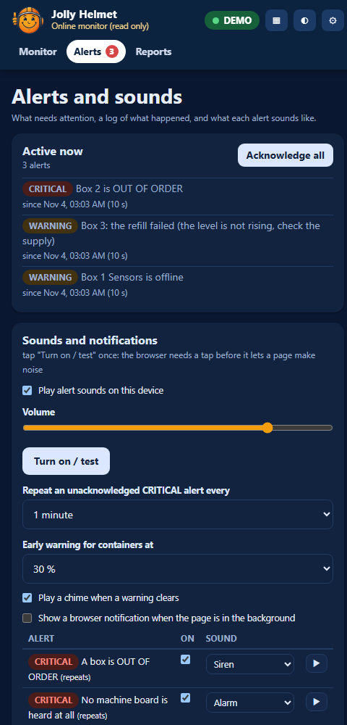
The Alerts tab: active alerts, the sound settings and the log (demo data)

A page that is closed, or a phone that is locked, cannot play a sound. For alerts on a closed page use the Blynk app (Technician guide, Online monitoring, Alerts when the page is closed).

Reports
- Revenue and customers per day for the last 14 days, with the 7-day average, and this week against the week before.
- Busiest hours and busiest days: when the customers come.
- What each box earns: sessions, revenue and the share of each box.
- Daily CSV, Last sessions CSV and Boxes and hours CSV open in Excel. Print / save as PDF makes a clean report page.
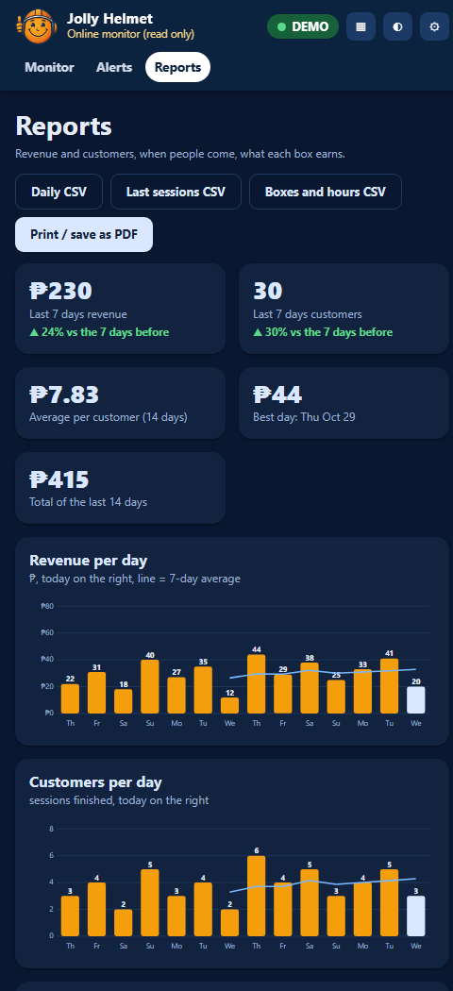
The Reports tab (demo data)

Reference (Safety, settings, policies and glossary)
Safety, settings, policies, glossary and index

Safety and emergencies
The customer side of every machine is safe to use. The dangers are behind the panels: 220 V mains, UV-C light, a hot heater and flammable alcohol. Read this page before you open anything.

In an emergency
- Stop the run. Touch CANCEL, then CONFIRM. A cancelled cleaning is dried for 3 minutes with UV light and warm air (AUTO DRY), a cancelled drying rests for 60 seconds (COOL DOWN), then the door unlocks. The coins are not refunded.
- If a door is forced open during a run, the machine shows SAFETY PAUSE and switches the UV-C, the mist and the heater off at once. It carries on when the door is shut again with the helmet inside.
- Fire, smoke, burning smell, sparks or a person in danger: switch the machine off at the wall socket or the main breaker, step back, and call for help. Do not use water on anything electrical.
- A helmet is stuck, or the power is off: do not force the door. Read "A helmet is stuck inside" below.

The solenoid locks are power-to-unlock: with the power off, or with a broken solenoid, they stay locked. Box 3 releases a trapped helmet by itself when it is out of order (see below). There is no mechanical release, so keep the UPS and the lock supply in good order. Staff can unlock the door from the Control Center: box page, Maintenance, ENCLOSURE LOCK.

A helmet is stuck inside
- Fastest way: tap CANCEL, then CONFIRM on the screen. After the short auto-dry (cleaning) or cool-down (drying) the door unlocks. If a door was forced open while the machine was running it pauses (SAFETY PAUSE) and the UV-C, the mist and the heater switch off. The helmet may be warm.
- Check that the machine has power. After a power cut, wait until the Devices line on the Control Center Dashboard shows the boards online again.
- Control Center, the box page, Maintenance, tap ENCLOSURE LOCK. The door unlocks for up to 60 seconds, then rests for 5 seconds. Tap Maintenance again when you are done.
- If the brain of the box stops answering for 15 seconds while a helmet is behind a closed door, the terminal board lets the enclosure lock go by itself.
- Box 3 with S3B alive but a sensor or relay board silent: the screen says OUT OF ORDER, and with a helmet shut inside the lock is released after 2 seconds and the screen board beeps (100 ms on, 500 ms off) until the door is seen open (180 seconds at most). The screen also says "Your helmet is still inside. Take it out, then close the door."
- Box 3 after a power cut (screen, sensor and relay boards on a UPS, S3 on mains): the S3 restarts. About 12 seconds after it is back, if nobody has paid yet and a helmet is still shut inside, it hands the helmet back first (OPEN B, the buzzer beeps), then returns to the start. A paid session that was cut by the power is not restored.
- These checks use Helmet counts as inside under (Box 3 page). Set it a little above the distance the sensor reads with a helmet inside (use live).
- Still locked? Follow the decision tree The door will not open in the Technician book.

Dangers inside the machine

Danger | Where | Rule
220 V mains | UV-C lamps, heaters, power inlet, fuses | Only a qualified electrician works on the mains side. Unplug first and wait before touching anything. The relays switch the live wire, so a clicking relay does not mean the wire is dead.
UV-C light | Box 1: 2 lamps, Box 2: 1, Box 3: 2 | UV-C harms eyes and skin. Never look at a lit lamp. Test a lamp only with the door closed. A door switch that cuts the lamp when the door opens is recommended.
Hot heater and air | Box 2 and Box 3 | Let it cool (the machine runs a cool down). Never cover the air intakes. The heater switched on by hand in Maintenance turns itself off after 5 minutes.
Alcohol | Containers in every box, the supply tank | Flammable. Keep it away from the heater, sparks and flames. Keep the lids closed and wipe spills at once. Keep a fire extinguisher near the machines.
Water and electricity | Valves, tubes, humidifiers, drain | Fix leaks straight away. Keep tubes and containers away from the boards and relay modules.
Door lock coils | 11 solenoid locks, 12 V | A coil held on for a long time overheats (once it caused a fire-risk incident). The machine never holds one on for more than 60 seconds in a row.

Safety features built into the firmware

Feature | What it does
Door during a run | Door opened mid-run: SAFETY PAUSE, UV-C, mist and heater off. The run resumes when the door is closed and the helmet is still inside.
Door shut, no helmet | While paused, if the door is shut with nothing inside, the lock is released so the door can be opened again.
Lock duty cap | A lock is never on for more than 60 seconds in a row, then it rests for 5 seconds.
Brain-loss watchdog | If a terminal hears nothing from its brain for 15 seconds, it switches the heater, UV-C, mist and coin power off.
Hand-set limits | In Maintenance the heater stops after 5 minutes, locks after 60 seconds.
Cool down | After drying, everything rests for 60 seconds by default so the helmet can cool (Box 2 also runs its fan). Also after a cancelled drying; a cancelled cleaning goes through its 3-minute auto-dry first.
Empty containers | When a box's container is EMPTY or LOW, or the Refilling Station is silent, only DRYING is offered; the station refills the container by itself.
Box 3 OUT OF ORDER release | Door shut with a helmet inside while Box 3 is out of order: the enclosure lock is released after 2 seconds and the buzzer repeats until the door is opened (S3B: 180 seconds at most; if S3B is dead, B3 uses up to three 60-second windows and B1 beeps up to 200 seconds).
Box 3 restart check | After a restart, 10 to 18 seconds after boot, if nobody has paid and a helmet is shut inside, S3B hands it back first (OPEN B). Once per start.
Refilling Station safety | The three valves are closed at power-up, only one valve is ever open, a valve is open at most 180 seconds, and a refill that does not rise is stopped and retried after 60 seconds.

First aid
- Electric shock: switch the power off first, then help. Do not touch the person while they are still in contact with a live part.
- UV-C in the eyes or on the skin: move away from the light, and see a doctor if the eyes hurt or the skin is red.
- Alcohol or cleaning liquid in the eyes: rinse with clean water for 15 minutes and get medical advice.
- Burn from the heater: cool it under cool running water and cover it with a clean cloth.

Who to call

Role | Name | Phone
Owner or supervisor | Sir Jolly Ropal | [Number]
Technician (MEJEZ STUDIO) | Jerahmeel Alzel M Mejes | 0975 791 5832
Electrician | Jerahmeel Alzel M Mejes | [0975 791 5832
Fire department | [Local number] | [Number]
Nearest clinic or hospital | [Name] | [Number]

Settings reference
Every setting you can change, with the value the firmware starts with and the range it accepts (a value outside the range is refused). Write the value you use in the last column. The firmware defaults are what a freshly flashed board starts with; the machine you are looking at may have been changed. Settings are saved inside the boards, so they survive a power cut and a LocalServer swap. Where to change them: Control Center, the box page or the Refilling Station page.

Prices and time (every box)

Setting | What it does | Default | Allowed | Yours
Coin rate | N coins buy X minutes (or seconds). The first N coins are the required coins on INSERT COIN. | 15 coins = 5 min (20 s a coin) | 1-500 coins, 0.1-9999 time
Most coins | Largest number of coins one session can take. | 90 | 1-999
Cool down | How long the cool down lasts after a drying, also after a cancelled drying. | 60 s | 5-900 s
Auto-dry | How long the auto-dry after every cleaning lasts (UV and the heater). | 180 s | 10-900 s
Heater off at the end | How long the heater is off at the end of the auto-dry. | 30 s | 0-900 s
Refilling Station offline after | The station counts as offline when it was not heard for this long: only DRYING is offered. | 15 s | 5-120 s

Sensors (every box)
The helmet sensor is the ultrasonic sensor that looks at the helmet. The container levels are not set on the box page: the Refilling Station reads them (see its table below). The default is a placeholder: measure your real helmet.

Setting | What it does | Default | Allowed | Yours
Helmet counts as inside under | The helmet counts as inside when its sensor reads under this. It also decides when a helmet is trapped during OUT OF ORDER. | 15 cm | 1-200 cm

Screen refresh (all boxes)

Setting | What it does | Default | Allowed | Yours
Refresh when a relay switches on or off | Which relay changes force a full re-initialisation of the touch screen (the white-screen cure). One tick per relay, for ON and for OFF. | Heater on; lock and heater off | Any relay
Auto refresh | Every N seconds the box re-sends the current page as a full re-init. | 2 s | 0 (never) to 60 s

Refilling Station
The Refilling Station keeps the main container of every box topped up from one supply, one valve at a time. The first four numbers and the next five are set per box (the forms on the Refilling Station page); the manual test length is for all boxes. The numbers are raw sensor values (0 when dry, growing as the liquid rises). For now only Box 3 is watched: the settings of Box 1 and Box 2 do nothing until WATCH_BOX is switched on for them.

Setting | What it does | Default | Allowed | Yours
Empty up to (per box) | At or under this raw value the container is EMPTY. | 0 | 0-4095
MID starts (per box) | Where MID starts. Above Empty up to and under this, the level is LOW. | 500 | 1-4095
HIGH starts (per box) | Where HIGH starts. | 1000 | 1-4095
MAX starts (per box) | Where MAX starts. The refill stops here. | 1200 | 1-4095
Waits for a rise when EMPTY | How long the level may stay flat while EMPTY before the refill FAILED. | 30 s | 1-600 s
Waits for a rise when LOW | The same while LOW. | 5 s | 1-600 s
Valve open at most | Longest time one valve may stay open. | 180 s | 10-1800 s
Tries again after | Pause before a failed box tries again (for ever). | 60 s | 5-3600 s
Counts as rising | Smallest step in the raw value that counts as a rise. | 10 | 1-500
Manual test length | How long Test valve opens a valve. | 2 s | 1-30 s

LocalServer and Online Server

Setting | What it does | Default | Allowed | Yours
Control Center Wi-Fi | Name and password of the LocalServer Wi-Fi. Open 192.168.4.1. | JollyHelmet-Local, 12345678 | Set in the firmware
Coin value | Pesos one coin pulse adds to the revenue. | 1.00 | Any positive number
Online Server setup Wi-Fi | Wi-Fi to open the setup page on. | JollyHelmet-Online, 12345678 | Set in the firmware
Send to Blynk every | How often the Online Server uploads. | 1 minute | 30 s, 1, 2 or 5 min
Time zone | Hours from UTC, for the daily revenue. | As set in the portal | -12 to 14
Extra datastreams, events, skip TLS check | V1 to V4, the alert event, and the certificate check. | Off, off, off | On or off
Blynk server | Server name. | blynk.cloud | Text
Public status device token | Token of a second Blynk device for the customer page (status.html). Type - to remove it. | Empty (not used) | A token
Reset statistics | Button in More settings: starts the per-box, busiest-hours and busiest-days counts again from zero. | - | Button
Bypass Safety 2 Seconds Relay | Box page, Maintenance. When ticked, relays you switch on by hand stay on until you switch them off. The heater still stops after 5 minutes and the enclosure lock rests after 60 seconds. | Off (relays go off after 2 s) | Tick or untick
OPEN A / OPEN B beep | Box page. Length of the beep and the wait between beeps while OPEN A or OPEN B waits for the door. Kept in the box. | 100 ms beep, 500 ms wait | Beep 20 to 1000 ms, wait 0 to 10000 ms (0 = one beep)
Date and time (clock) | Settings tab. Set by a phone when the Control Center is opened after a power-on, or typed by hand. A power cut loses it. | Phone's time | Any date and time
Restore from backup CSV | Settings tab. Puts back the sessions of an unchanged Download log (CSV) file. The totals are raised to at least the log's tally. | - | A CSV exactly as downloaded
Previous data (history.json) | Settings tab. Customers from before the log existed, drawn lighter in the chart and counted in the Finished and cancelled card. Never a name. | None | Up to 1000 rows, 64 KB
Crash reports | Settings, This board. The last restarts kept on the board. Delete these reports clears them. | None | The last 3 are kept

Online web page (kept in each browser)

Setting | What it does | Default | Allowed | Yours
Refresh every (Settings window) | How often the page reads Blynk. | 10 s | 5, 10, 30, 60 s
Early warning for containers (Alerts tab) | The dial turns amber and a notice alert starts here. | 30 % | Off, 20-40 %
Play alert sounds, Volume | Master switch and loudness on this device. | On, 80 % | On or off, 0-100 %
Repeat a critical alert every | An unacknowledged critical alert sounds again. | 1 minute | Never, 30 s, 1, 2, 5 min
Sound of each alert | Which sound, or none, each kind of alert plays. | See Alerts and sounds | 9 sounds or silent
Chime when a warning clears | Plays when an alert goes away. | On | On or off
Browser notifications | A notification when the page is in the background. | Off | On or off
publicToken (js/config.js) | Token of the public status device for the customer page. | Empty (the QR address carries it) | A token
prices, contact (js/config.js) | Texts on the customer page. | The firmware prices | Any text

Fixed values (not settings)

Value | Where it comes from
Radio channel 1 | ESP-NOW and the Wi-Fi of the LocalServer must stay on channel 1.
15 s watchdog | No sign of the brain for 15 s: relays off, a trapped helmet is released.
60 s lock, 5 s rest | A lock never stays on longer than that.
5 min heater | Limit of a hand-set heater, in Maintenance.
Coin signal on GPIO 23 | On A1 and B1 (C1 uses GPIO 32).
Box 3 helmet release | OUT OF ORDER with a helmet shut inside: lock released after 2 s, buzzer 100 ms on / 500 ms off, at most 180 s (S3B) or three 60 s windows (B3). Restart check 10 to 18 s after boot.
One valve at a time | The Refilling Station never opens two valves. Valves are closed at power-up and open at most 180 s.
Sensor health | A water-level sensor at 4090 raw or more (3.3 V rail), or jumping by more than 1500 raw within a second while its valve is closed, for 5 s = SENSOR FAULT; it clears after 10 s of normal readings. Not a setting.
Coin counting wait | After the required coins are reached, INSERT COIN waits until no new pulse has been seen for 1.5 s (at most 6 s), so a big coin is counted in full and all of it buys time. Not a setting.

Policies
What the machine does is fixed by the firmware. The rules around it are the owner's decisions. Items marked confirm are proposals: edit them to match what the owner decides, then post the customer rules at the machine.

Coins and refunds

Situation | What the machine does | Policy
Customer cancels a run | Asks CONFIRM or RESUME and warns that coins will not be refunded. The coins are not refunded. | No refund after a run starts.
Customer cancels while inserting coins | Asks YES or NO and warns that coins will not be refunded. The machine does not return coins already inserted. | No refund after inserting the coin
Fault or power cut during a run | The run stops. The station releases a trapped helmet and beeps. The machine does not return coins, and a session cut by the power is not restored. | A power cut is outside the owner's control: no refund by default. Staff may still decide to help (confirm).
Machine OUT OF ORDER | It does not take coins. | A sign: use another machine.
Too few or too many coins | INSERT THE REQUIRED COIN asks for the required coins (15 by default). More coins can be added while a run is going, up to 90 coins in all. | Posted on the machine.
No change is given | The slot takes coins only. | Say so on the sign.

Using the machine
- Motorcycle helmets only. Take out gloves, phones, cameras and speakers first.
- Children use the machine with an adult.
- The owner is not responsible for items left inside or for damage that comes from a helmet's own condition. Nothing is stored in the machine after a run.
- The machine cleans and dries. It does not guarantee that every smell or every drop of water is gone.

Data and privacy
- The machines have no camera and no microphone. They record only counts: sessions, coins, minutes and the state of each board.
- The machines and the LocalServer store no names, no phone numbers and no payment cards. Payment is coins only. The one exception is the optional nickname a customer can type on the customer status page: it is public to everybody who opens the page, it lives only in the public Blynk device while the cycle runs, and it clears when the cycle ends.
- The backup log (CSV) and the previous-data file (history.json) hold only dates, times, boxes, coins, minutes and Finished or Cancelled. Keep them like any other record of the business. The CSV ends with a check line, so a copy that was edited is refused by the LocalServer.
- The Online Server sends only totals and status to Blynk. The Blynk token is a secret: keep it out of the manual, the web page and any file that is shared.
- The customer status page shows only whether each machine is free, in use or out of order. The public Blynk device behind it holds nothing else.
- The Control Center and the setup Wi-Fi use a password printed in this manual. Change both before the machines are used in public, and give the admin and technician parts of this manual only to the team.

Staff and safety
- Only trained staff refill the containers, open the panels or use Maintenance.
- Mains work is for a qualified electrician (see Safety and emergencies).
- Run the weekly and monthly checks in the Maintenance chapter and write the date down.
- Alcohol and cleaning liquid: keep the supplier's safety data sheet near the machines. Decide where the drain water may go.

Operating hours and notices

Item | Decision
Operating hours | 9:00 AM – 5:00 PM
Where to report a fault or a lost item | MEJEZ STUDIO || 0975 791 5832
Price list posted at the machine | Prices and time chapter, or the printable panel cards.

Glossary
Words used in this manual, in plain language.

Term | Meaning
2-second safety | In Maintenance a relay you switch on by hand switches itself off after 2 seconds, done by the box itself. The coin power is exempt. See Bypass Safety 2 Seconds Relay.
Acknowledge | The button on the online page that stops a repeating alarm. A new alert still sounds.
ACS | Auto Container System. The two refill boards used before 2026-11-03; the Refilling Station replaced them.
Alert sound | The beep pattern of one kind of alert (siren, alarm, three beeps, two tones, chime...). Each can be changed in the Alerts tab.
Allan coin acceptor | The coin slot. It sends one pulse for each coin value it accepts.
Auto dry | The drying that ends every cleaning: UV light and the heater for 3 minutes by default, the heater off for the last 30 seconds.
Backup log (CSV) | The file that Download log (CSV) gives you: every session the machines recorded, with date, time, box, coins and minutes. Keep copies: Restore from backup CSV reads it.
Blynk | The online service the Online Server sends its snapshot to. The web page reads it from there.
Brain | The ESP32-S3 board of a box (S3A, S3B, S3C). It runs every step and keeps the settings. A box has one brain and several terminals.
Bypass Safety 2 Seconds Relay | The Maintenance tick box that turns the 2-second safety off, so hand-set relays stay on until you switch them off.
Captive portal | The page that opens by itself when a phone joins the setup Wi-Fi of the Online Server.
Channel 1 | The radio channel all the boards use for ESP-NOW. The LocalServer Wi-Fi stays on it too.
CHECKING | The 2-second "Checking Main Container" screen after the first tap: the box reads the Refilling Station.
Control Center | The pages of the LocalServer (Dashboard, Settings, Box 1, Box 2, Box 3, Refilling Station) where settings, calibration and Maintenance are done.
Cool down | The time after drying when nothing heats and the helmet can cool (60 seconds by default). Box 2 also runs its fan.
Crash report | A note the LocalServer keeps in its own flash after a restart it did not plan (the last three are kept). Read it in Settings, This board, and send a screenshot to the developer.
Customer status page | status.html: the public page that shows which machine is free, in use or out of order.
Dashboard | The first tab of the Control Center (called Home in older pages): the three boxes, the Refilling Station, the statistics and the Devices line.
Datastream | A named value in Blynk. This project uses V0 (a text) and, if you switch them on, V1 to V4.
Day viewer | The card that opens when you tap a bar of the Daily chart or pick a date: the customers of that day, with a Machine tab and a JSON tab.
DC-DC module | The power module that turns 12 V into 5 V and 3.3 V for the boards, sensors and small loads.
Devices line | The line on the Dashboard that says how many boards answer (for example 12 of 12 online). Tap it for the badge of every board.
Early warning | The level (30 % by default) where a container dial turns amber and a notice appears, before the box runs out.
Enclosure lock | The solenoid lock of the main door of a box. It is the one released for a trapped helmet.
ESP-NOW | The radio link the boards talk over. No router is needed.
ESP32 and ESP32-S3 | The two kinds of board. The plain ESP32 boards are terminals. The S3 boards are brains and servers.
GPIO | A numbered pin of an ESP32 board.
history.json (previous data) | The file of customers the team collected from its own records before the log existed. The chart draws it lighter and the Finished and cancelled card counts it, but it never changes the machine log, the totals or the CSV.
Humidifier | The ultrasonic mist maker (5 V). Three of them make the mist during CLEANING.
Integrity line | The last line of the backup CSV. It lets the LocalServer refuse a file that was edited or saved again. It protects against mistakes; it is not a lock.
JD-VCC | The separate power input of a relay module's coils, with a jumper to the logic supply.
Level (EMPTY, LOW, MID, HIGH, MAX) | How full a main container is, worked out by the Refilling Station from its water-level sensor and the four edges set for that box.
Level dial | The half-circle gauge of a container on the Monitor tab. Red = EMPTY or LOW, green = MAX.
LocalServer | The board that makes the JollyHelmet-Local Wi-Fi and the Control Center, and counts the revenue.
Main controller | The plain name of a box's brain (S3A, S3B, S3C).
Maintenance mode | A page where a technician switches relays by hand. The machine shows MAINTENANCE. Hand-set relays go off after 2 seconds unless the safety is bypassed.
Mist | The fine vapour of the cleaning liquid that the humidifiers make during CLEANING.
Navigation bar | The row at the top of every Control Center page: Dashboard, Settings, Box 1, Box 2, Box 3, Refilling Station.
Nickname | The optional name of up to 12 characters a customer can type on the status page while the cycle runs. It is public and clears when the cycle ends.
NOT WATCHED | What the Refilling Station reports for a box it does not serve (Box 1 and Box 2 for now): no level, no refill, no warning. Set by WATCH_BOX in the station's sketch.
NVS | The memory inside a board where settings are saved (they survive a power cut).
Online Server | The ESP32-S3 that listens to the machines and sends a snapshot to Blynk. It never controls anything.
OUT OF ORDER | The screen shown when a box cannot serve customers.
Power-to-unlock | A lock that opens only while it has power. With no power the door stays locked.
Public status device | The second Blynk device whose token may be public. It holds only the step and time left of each box.
QR code | The square code on the sign at each machine. A phone camera opens the customer status page with it.
Queue | The containers waiting for the Refilling Station's valve: EMPTY first, then LOW, first come first served.
Refilling Station | The one board with three water-level sensors and three valves that keeps the main containers full. For now it watches and refills Box 3 only. It replaced ACS 1 and ACS 2.
Relay | An electrically operated switch. The boards use relays to switch locks, mist makers, lamps and the heater.
Required coins | The number of coins INSERT COIN asks for: one step of the coin rate (15 coins in the default).
SAFETY PAUSE | The screen shown when a door opens during a run. The loads switch off until the door is closed.
SELECT DRY ONLY | The mode screen with CLEANING greyed out: the liquid is low or the Refilling Station is not answering.
SENSOR FAULT | What the Refilling Station reports for a container whose water-level sensor reads on the 3.3 V rail or jumps about wildly. The box offers drying only until the reading is normal for 10 seconds.
Serial Monitor | The Arduino IDE window that shows what a board prints over USB (115200 baud).
SoftAP | A Wi-Fi network made by a board itself (JollyHelmet-Local, JollyHelmet-Online).
Terminal | A plain ESP32 board that holds a box's sensors, relays and display. It follows its brain.
TFT | The 2.8 inch colour touch screen of a box.
Token | The secret key that lets the Online Server write to your Blynk template. Keep it private.
Ultrasonic sensor | The HC-SR04. It measures the distance to the helmet or to the liquid in a container.
UPS | A battery backup. In Box 3 it keeps the screen, sensor and relay boards alive during a power cut, so the helmet can be released.
UV-C lamp | The 220 V germicidal lamp. Never look at it when it is lit.
Valve | The normally closed solenoid valve that lets water into one main container when the Refilling Station opens it.
Watchdog | A safety check: if a board stops hearing its brain for 15 seconds it switches its loads off.

Index
Page numbers refer to this manual. In the Word file, right-click the index and choose Update field to refresh it after editing.

2-second safety (Maintenance), 19
A3 (Box 1 relay board), 26
Alerts and alert sounds, 29, 40
B3 (Box 3 relay board), 26
Backup log (CSV) and restore, 10, 11
Calibration, 25
Captive portal, 38
Coin value and revenue, 26
Control Center, 6
Cool down, 34, 35, 37
Crash report (stored on the board), 13
Customer names (nickname), 41
Dashboard (Home page), 6, 7, 8, 25
Day viewer (customer by customer), 8
Emergency, 42
ESP-NOW and channel 1, 40
Finished and cancelled sessions, 8
Fuse, 35
Integrity line (CSV check), 11, 12, 42
Level dials (early warning), 22, 27, 29, 40
LocalServer, 6, 26
Maintenance mode, 15, 19, 26
Navigation bar and Devices line, 7, 8, 25, 26
Online page, 27
OPEN A / OPEN B beep, 18
OUT OF ORDER, 19, 25, 34, 37
Policies and refunds, 41
Power cut (power-to-unlock), 34, 37, 41
Previous data (history.json), 8, 42
Prices, 42
QR code, 27
Refilling Station, 8, 20, 22, 27, 37
Relay, 18, 25, 26
Reports tab (busiest hours, box earnings), 27, 30
S3A (Box 1 brain), 26
S3B (Box 3 brain), 26
S3C (Box 2 brain), 26
SAFETY PAUSE, 34, 35
Screen refresh (white screen), 17, 25
Token (Blynk), 42
Touch screen (TFT), 17
Trapped helmet, 34, 40
UPS, 34
V0 datastream, 39
Watchdog (15 seconds), 35, 40
Web page (monitor), 42
Wi-Fi JollyHelmet-Local, 6, 38

Thank you for using
Jolly Helmet
We hope to see you again!
Make your Helmet Happy Again.
MEJES, JERAHMEEL ALZEL M.
CRUZ, DEAN RYAN P.
MENDOZA, RICAH S.
MARTOS, KRISTINA E.
DEVELOPERS AND DESIGNERS
USER MANUAL - ADMIN GUIDE

